**\*Design is in the bottom**

**ANALYSIS**

In assignment 3 we are creating a shopping management software structure which accounts for three different types of objects to shop for: Electronics, Groceries, and Clothing. Each of the three types of objects share base characteristics defined by the Items superclass. Each item must have a name, weight, price, and quantity. However, each type of object have unique characteristics. Clothing objects may not be shipped by premium shipping, unlike the other two classes they have standard shipping only. Groceries must be marked as perishable or nonperishable, and are not taxed. Electronics must be marked as frail or not frail and are taxed depending upon the state. Finally, the program must read its shopping commands from an input file designated by *** command line? ****, which may specify that the shopping inventory be updated with a new object, that an object be searched for within the shopping cart inventory, that an object be deleted from the shopping cart inventory, that the quantity of an object be updated, and finally may specify that a summary of the shopping cart inventory be printed which includes the name, weight, price (including tax and shipping charges), and quantity of each object. The shopping cart program must reject invalid commands and must print the contents of the shopping cart by name.

**Design**

**System Level Use Diagram**

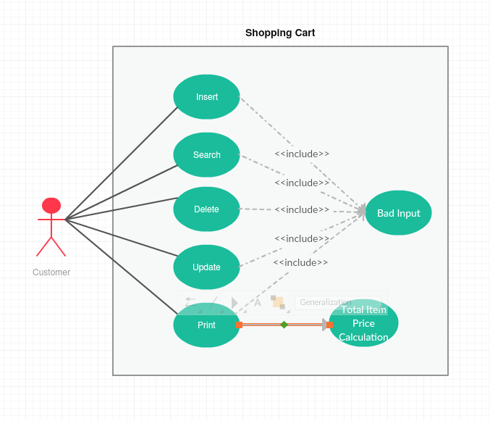

**UML Model**

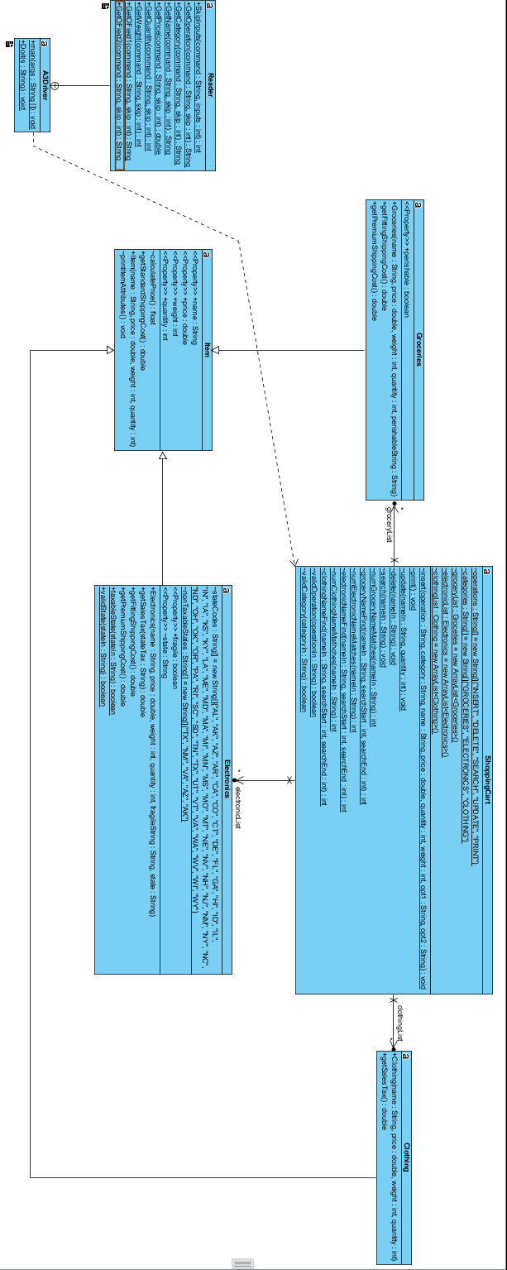

**ADT Level Description**

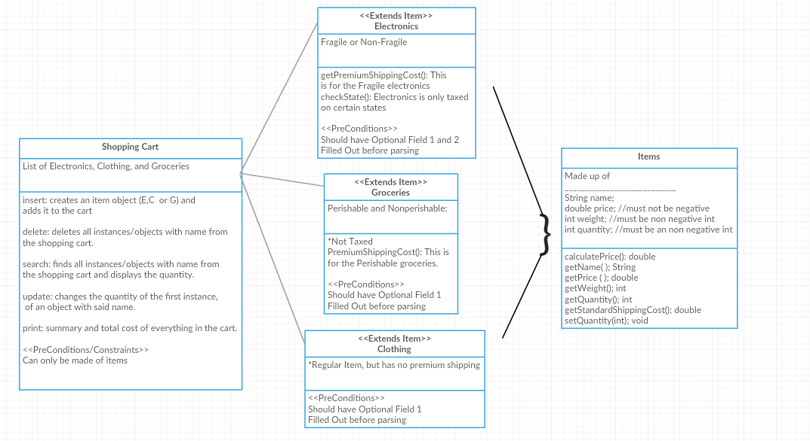

**Function Block Diagram**

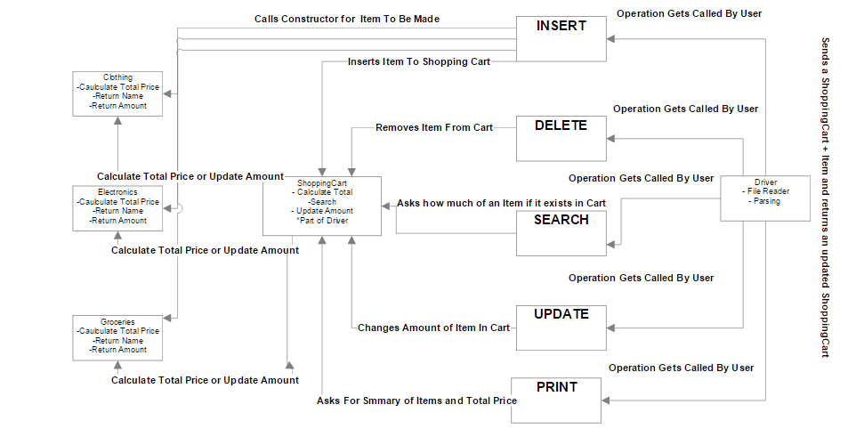

**Driver Algorithm**

* Open File
* Read Contents and Convert To A String
* Parse Operation like below into different variables in an eloquent error free fashion:

“<operation> <category> <name> <price> <quantity> <weight> <optional field1> <optional field2>”

* Send Arguments to ShoppingCart Class
* Continue Reading File to It is done.